**SOLO Taxonomy and student learning**

Solo Taxonomy is a **systematic** way that describes how learners' understanding build from **easy to difficult** while learning different tasks or subjects. The Solo Taxonomy can be used to enhance the **quality** of learning within the classroom teaching and provide a systematic way of developing deep understanding (Damopolii, 2020). Student learning can be guided in ways that promote deep learning.

‍

**What is SOLO taxonomy?**

SOLO (**Structure of Observed Learning Outcomes**) offers a **structured outline**for the learners to use to **[build their learning and thinking](https://www.structural-learning.com/learning-skills-framework)**. It motivates students to **ponder** where they are presently in terms of **their level of understanding**, and what they must do to **progress**.

‍

**Five Stages of Solo Taxonomy**

**Biggs and Collis**defined the **[Structure of the Observed Learning Outcomes](https://www.sec-ed.co.uk/best-practice/pedagogy-the-solo-taxonomy-and-constructive-alignment)**produced by learners on basis of complexity. Their proposed model explained levels of [growing complexity](https://www.structural-learning.com/post/stretch-and-challenge-a-teachers-guide) in a learner’s understanding of performance tasks or subjects. There are **five stages of understanding**of SOLO Taxonomy. It's levels are **hierarchal** and each level is affected by the **previous** level and contributes something to it.

‍

As well as providing classrooms with a language of learning, the learning verbs can also be used to create assessment tasks. The complexity of student response can be increased as their depth of understanding grows. The student response can be used to develop a coherent understanding of subjects.

‍

**SOLO taxonomy as an alternative to Bloom's Taxonomy**

In 1982, **[Biggs and Collis](https://www.researchgate.net/profile/John-Biggs-3)** devised The SOLO Taxonomy (Structure of Observed Learning Outcomes) as an alternative of Bloom’s Taxonomy (Cognitive Domain). From several decades, **Bloom’s Taxonomy**has been used to build learning and teaching strategies. Bloom’s classifies learning from **simply memorizing** to more **complex cognitive process**such as evaluating and analyzing.

‍

The **Solo Taxonomy** offers a measure of understanding of [**thinking**](https://www.structural-learning.com/post/getting-started-with-metacognition) or **cognitive learning outcomes** that most of the teachers feel comfortable adopting. The **hierarchical** model of Solo Taxonomy is **comprehensive**, provided with **objective criteria**, and used for a variety of **subjects** and for a variety of **assignments**. Teachers like how SOLO indicates student [learning](https://www.structural-learning.com/post/in-the-moment-planning-a-teachers-guide) using diverse material in levels of **[increasing structural complexity](https://www.structural-learning.com/post/rosenshines-principles-a-teachers-guide)**, and that these levels show a similar pattern across tasks.

‍

‍

**Bloom's Taxonomy Vs Solo Taxonomy**

1. The Bloom's taxonomy implies that there is an essential relationship between the **questions** asked and their **responses**; whereas, both the question and answer can have a **different level**in SOLO taxonomy.
2. Bloom's Taxonomy differentiates '**[knowledge](https://www.structural-learning.com/post/knowledge-organisers-a-teachers-guide)**' from the **intellectual processes**or **abilities** that function on this 'knowledge' whereas the SOLO taxonomy is at its core based upon the **processes of understanding** used by the learners when responding to the prompts. Hence, knowledge pervades across each level of the **SOLO taxonomy.**
3. Bloom argues that his taxonomy does not only **relate complexity**but also relates a sequence of difficulty; whereas, there is no such requirement of **increasing difficulty** in case of the SOLO method.
4. Bloom’s taxonomy does not accompany criteria for **guessing** the results of any activity; whereas, SOLO taxonomy is precisely useful for **guessing** the **outcomes (Crompton, 2019).**
5. Both taxonomies along with the [Universal Thinking Framework](https://www.structural-learning.com/thinking-framework), enable children to talk about their learning more effectively.

‍

**Five Hierarchical Levels of Understanding**

The SOLO Taxonomy has **five** hierarchical levels of understanding and all the stages include the **previous stage**and adds something to it.

‍

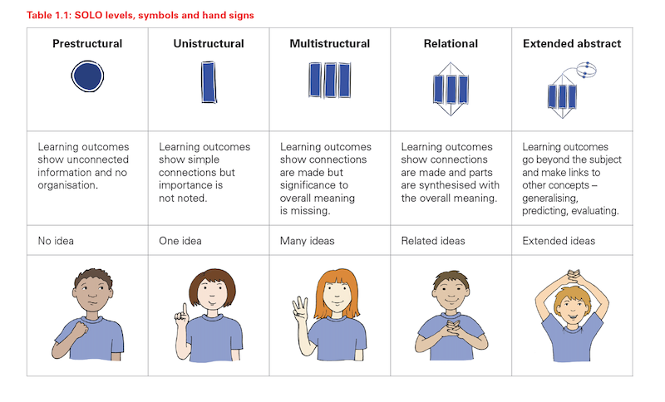

(Acquired from Biggs, 2011)

1. **Pre-structural level**

This is an incompetent stage, where learner does not know anything about the task or the subject. At this stage, the student simply gets unconnected information, which has no sense or organization. The student remains unable to understand the information; hence, he does not demonstrate understanding.

‍

1. **Unistructural level**

This is a stage, when learner knows just a single relevant aspect of a task or a subject. At this stage, the student only knows about the basic concept of the task or the subject. Therefore, a student can make easy and apparent connections; but, he does not know the broader significance of the information. The students' response indicates concrete understanding of the task, but it pays attention to only one relevant aspect.

‍

1. **Multistructural level**

At this stage, the student knows numerous relevant independent aspects. Although, the learners understand the relationship between different aspects but it's relationship to the whole remains unclear. Concepts and ideas about a topic are not connected. The students can make several connections, but they do not understand the significance of the whole. The students’ response is based upon some relevant aspects, but their responses are treated independently.

‍

1. **Relational level**

This is a stage where aspects of knowledge are combined to form a structure. At this stage, the student is able to understand the importance of different parts in relation to one whole. Concepts and Ideas are connected, and they offer coherent knowledge of the whole. The students' response shows an understanding of the task by being able to combine all the parts. Students can demonstrate how the each part contributes to the whole.

‍

1. **Extended Abstract level**

This is a stage where knowledge is generalized to build a new domain. After reaching this level the students do not only make connections within the provided task but they also create connections beyond it. Students can transfer and generalize the concepts and principles from one subject area into another domain. The students' response shows that they can conceptualize beyond the level of what has been taught. They are able to propose new concepts and ideas on basis of their understanding of the task or subject being taught.

‍

**Why is The SOLO Taxonomy a good fit for Hattie's ideas?**

[**John Hattie**](https://edcentral.uk/edblog/beginner-guides/a-beginners-guide-to-professor-john-hattie) is an advocate of [SOLO Taxonomy](https://www.challenginglearning.com/portfolio/solo-taxonomy/). Hattie has divided it in a manner which is easier for the learners to understand, and allows learners to assess their own learning. According to Hattie, teachers can use:

1. **No Idea** - (like the pre-structural level)
2. **One Idea** - (like uni-structural level)
3. **Many Ideas** - (like multi-structural level)
4. [**Relate**](https://www.structural-learning.com/post/thinking-maps-for-deeper-learning) - (like relational level)
5. **Extend** - (like extended abstract)

‍

[[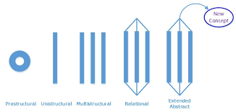](https://www.structural-learning.com/post/graphic-organizer-templates-a-teachers-guide)](https://www.structural-learning.com/post/graphic-organizer-templates-a-teachers-guide" \t "_blank)

[SOLO visualised](https://www.structural-learning.com/post/colourful-semantics-a-teachers-guide)

**Why is Solo Taxonomy useful?**

Solo Taxonomy is useful because:

1. It helps learners to **[reflect meaningfully](https://www.structural-learning.com/post/how-to-develop-metacognition)**on what the next levels in their learning are.
2. It helps instructors to thoughtfully **design** learning experiences and learning intentions.
3. It is used by the teachers and students **together**.
4. It makes it convenient to **identify** and **implement** effective success criteria.
5. It offers **feedforward** and **feedback** for the learning outcomes.
6. Students **understand** the reasons for everything they do and realise **improvements** are due to their own strategies
7. It shows the **difference** between **deep** and **surface** understanding, helping learners understand where they are on that spectrum, and what they must do to **progress**.

‍

‍

[[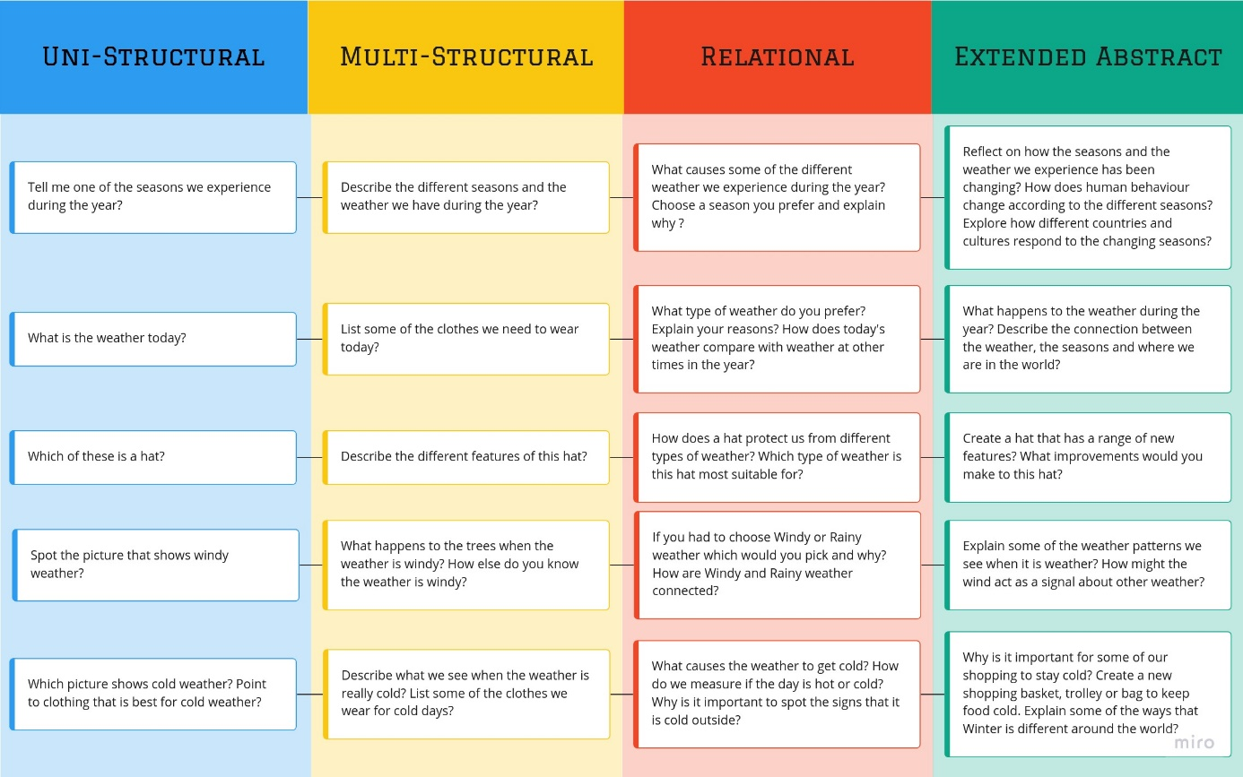](https://www.structural-learning.com/post/spaced-practice-a-teachers-guide)](https://www.structural-learning.com/post/spaced-practice-a-teachers-guide" \t "_blank)

[SOLO examples related to the weather](https://www.structural-learning.com/post/rosenshines-principles-a-teachers-guide)

‍

‍

How does the Universal Thinking Framework build on the SOLO Taxonomy?

Like the SOLO taxonomy, [the universal thinking framework](https://www.structural-learning.com/thinking-framework" \t "_blank) is used to increase the depth of student understanding by building cognitive structures or schemas. The taxonomy helps classrooms develop a strong language for learning that can be used to guide classroom practice in productive ways.

‍

The colour-coded nature of the command words enables educators to create simple procedures that un-complicate the learning process. This improves engagement in learning as the language can be used to devise a challenging question that keeps students on their toes. Used in both Primary and Secondary schools, the Universal Thinking Framework can be used to advance complex [thinking skills](https://www.structural-learning.com/post/cognitive-abilities-test) and depth of knowledge. You can learn more about the framework here: <https://www.structural-learning.com/thinking-framework>

‍

[[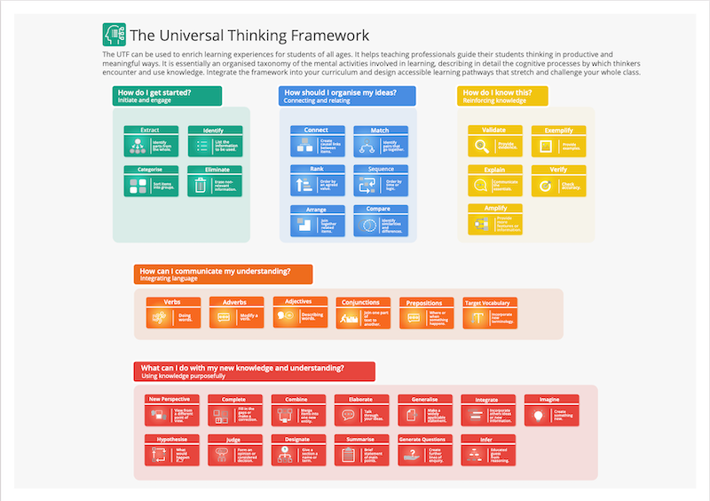](https://www.structural-learning.com/post/differentiation-strategies-a-teachers-guide)](https://www.structural-learning.com/post/differentiation-strategies-a-teachers-guide" \t "_blank)

[The Universal Thinking Framework](https://www.structural-learning.com/thinking-framework)

**References to SOLO Taxonomy**

Biggs, J., & Collis, K. (1989). Towards a model of school-based curriculum development and assessment using the SOLO taxonomy. Australian journal of education, 33(2), 151-163.

Biggs, J. B. (2011). Teaching for quality learning at university: What the student does. McGraw-hill education (UK).

Crompton, H., Burke, D., & Lin, Y. C. (2019). Mobile learning and student cognition: A systematic review of PK‐12 research using Bloom’s Taxonomy. British Journal of Educational Technology, 50(2), 684-701.

Damopolii, I., Nunaki, J. H., Nusantari, E., & Kandowangko, N. Y. (2020, June). The effectiveness of [Inquiry-based learning](https://www.structural-learning.com/post/a-teachers-guide-to-inquiry-based-learning) to train students’ thinking skill based on SOLO taxonomy. In Journal of Physics: Conference Series (Vol. 1567, No. 4, p. 042025). IOP Publishing.

Other Links

Want more? Here is a link on Problems with Bloom's Taxonomy (Invalid, unreliable, impractical) Want to dive into SOLO model? Check out Pam Hook's Website. Start with these two introductory books: [(pamhook.com)](http://pamhook.com/)

‍

To review the SOLO taxonomy you can view three minutes of the video Understanding, from Teaching Teaching & Understanding Understanding, section 3 (3:15 – 6:18). [(youtube.com)](https://www.youtube.com/watch?v=SfloUd3eO_M&feature=youtu.be&t=3m15s)

‍

SOLO Taxonomy: A Guide for Schools Bk 1: a Common Language by Julie Mills and Pam Hook SOLO Taxonomy: A Guide for Schools Bk 2 by Pam Hook Julie Mills Leave a reply © 2019 Eductechalogy. All rights reserved. [(amazon.com)](https://www.amazon.com/SOLO-Taxonomy-Guide-Schools-Paperback/dp/B00JYHGPEK/ref=sr_1_2?ie=UTF8&qid=1499107790&sr=8-2&keywords=solo+taxonomy%3A+a+guide)